Training Course for Those Who Would Like to Work as a Caregiver

You Get Paid Monthly While Taking this Course

Helper’s license granted.
(Careworker Induction Training)
You also can build up LTC Terminology in Japanese

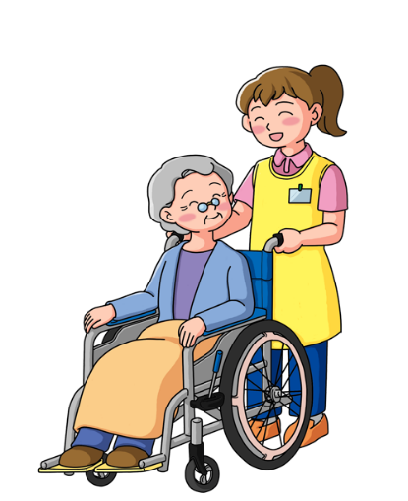
◆Application Method | Through Phone Call:  0586-47-6727 ※There will be an interview and a written test
◆Number to be Admitted | １6
◆Application Period | Seｐ 20th,（Tue）2022  ※We will close as soon as the capacity is reached
◆Requirements | ・Foreign residents who are looking for a job (Those who have no limit for employment)  ・Those who are able to read and write Hiragana, Katakana and speak Japanese  ・Those without Helper’s license  ・Those who want to be employed as a permanent full-time care worker
★Salary/20days （work Requirements） | Classroom lecture：163,040 yen with transportation  OJT：182,880 yen with transportation
★Employment  Period | Oct. 3, 2022 ～ Feb. 28, 2023 (Covered by Social Insurance)
★Time・Holiday | Classroom lecture：8：30～１７：３０（No work on Sat., Sun，holiday.）  OJT：Same as the training site（No work on Sat., Sun）
★Place of  Employment | Training at：Aichi-ken, Ichinomiya-shi, Shinsei, 3-17-21  Nagata Mansion, 1st floor  OJT at：Care facilities inside Aichi Prefecture
【Contact】 Avance Life Support Co., Ltd.
０５８６-４７-６７２７
Contact：Nishibu
Open Hours：Mon-Fri, 8：30～17：30
※ Avance Life Support Corporation is entrusted by Employment Promotion Division, Bureau of Labor, Aichi Prefectural
Government in implementing this project.
※ The monthly salary amount varies depending on the training days and content of the training.

